
Disability Inclusion Strategy
  - Media Studio / Teaching Block 1 Production report

Student Name: Samuel Williams-Hicks
Student ID: 25032028

Pre-Production

Ideation
In this section, please replace the texts and provide details of your team research in one of the United Nation Sustainable Development Goals:
The Goal: Mainstream rights of people with mental and psychical disabilities through all UN programs, Align major global framework such as “The Convention on the Rights of Persons with Disabilities (CRDP)” and “the 2030 Agenda for Sustainable Development”. And foster equality of outcomes to create an inclusive culture within the UN system.
Chosen concept: (of your Audio-Visual Project)
Chosen Call to Actions: United Nations 10th goal - Reduce inequality within and among countries
Related References: United Nations disability inclusion strategy

You could use Artificial intelligence-generated and third-party images for ideation purposes. However, using these images to produce the final video is PROHIBITTED.

Script
If you had used Generative AI to generate the script, please follow the instruction of UWE Harvard https://www.uwe.ac.uk/study/study-support/study-skills/referencing/uwe-bristol-harvard#personalcommunications to provide references in your report. If you had use Generative AI to generate the script and revised it manually, please attached the final version of your script, along with the original scripts / communication history with Generative AI.

Script:
[Scene 1 – Soft music. Three icons fade in: a wheelchair, a heart, and a thought bubble.]
Narrator:
This is Aisha, Daniel, and Mei.
Aisha uses a wheelchair.
Daniel lives with a condition you can’t always see.
Mei experiences mental health challenges.
[Scene 2 – Icons shift: a closed door, steep stairs, and a cloud of thunder.]
Narrator:
They face barriers every day — not just physical ones, but also prejudice, exclusion, and misunderstanding.
[Scene 3 – The UN logo appears, sending out waves that clear the barriers.]
Narrator:
The United Nations Disability Inclusion Strategy is changing that — challenging discrimination and creating access for all.
[Scene 4 – Other people appear to connect and form a bright, inclusive circle representing community and equality.]
Narrator:
Because reducing inequality means more than removing steps — it means opening minds.
[Final Scene – SDG 10 icon shines with text: “Equal Means Everyone.”]
Narrator:
When everyone is valued and included, the world moves forward together.

Storyboard
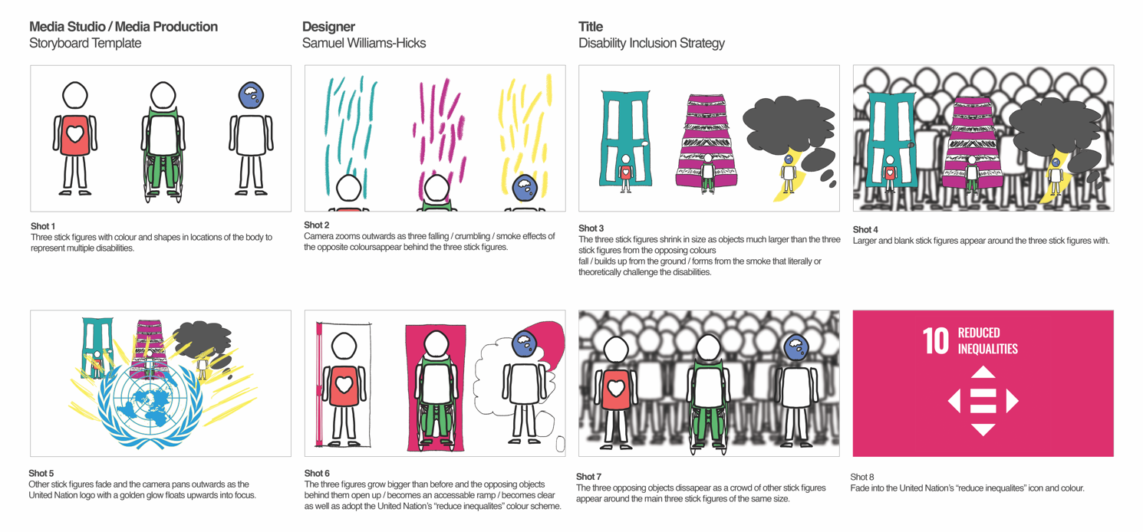

Post-Production

Production of Assets & VFXs
Please remove these paragraphs and briefly describe the process involved in producing your audio and visual assets and incorporating the visual effects during post-production.
For this assignment, you should independently produce all the audio and visual assets. Using images and videos provided by third parties or generated by Artificial Intelligence, including but not limited to Adobe Firefly, DALL.E, and Midjourney, is prohibited.

Reflective Statement
In this section, please remove this paragraph and reflect on the process of producing the video. Things you have done excellently, and things you could try another approach.

References
Please attach references, including your communication history with Generative AI, images, books, and journals during ideation, and audio sources, including background music and sound effects. Additionally, if you added extra Special Effects of After Effects from Online Tutorials, please add the links to this reference list.
Please strictly follow the UWE Bristol Harvard when referencing. https://www.uwe.ac.uk/study/study-support/study-skills/ referencing/uwe-bristol-harvard

