
Project Title
  - Media Studio / Teaching Block 1 Production report

Student Name: Kelsi Heywood
Student ID: 25040083

Pre-Production

Ideation
The goal is to show people how much work farmers put in to make sure people have food on their tables, and how that without them we wouldn’t have any food
My chosen concept of my Audio-Visual Project is how farming helps in stopping world hunger
The shosen Call to Actions (CTA) of our Audio-Visual Project is Ending World Hunger
Here are some of my references of the resources I used:
AJ Heywood & Sons Instagram page and YouTube channel
Kevin, H. (1989) aj_heywood_and_sons[Instagram]. Available from: https://www.instagram.com/aj_heywood_and_sons [Accessed on 10 November 2025]
Kevin, H. (1989) A J Heywood and Sons[YouTube]. Available from: https://www.youtube.com/@ajheywoodandsons8800 [Accessed on 10 November 2025]
Asked my dad for information on modern technology within Farming
As I’m from a farming background I knew a lot of the information beforehand

You could use Artificial intelligence-generated and third-party images for ideation purposes. However, using these images to produce the final video is PROHIBITTED.

Script
Every seed planted is a step toward ending hunger. Farming is more than hard work—it’s humanity’s greatest tool for nourishment and survival.
Across the world, farmers provide the food that sustains billions. But with access to modern technology, sustainable methods, and fair support, they can grow even more—feeding families, creating jobs, and strengthening communities
When we invest in farming, we invest in people. We reduce poverty, empower local economies, and make sure no one goes to bed hungry.
Because ending hunger starts where it always has—with those who grow our food.
Support the farmers. End hunger.

- Voice Over

Storyboard
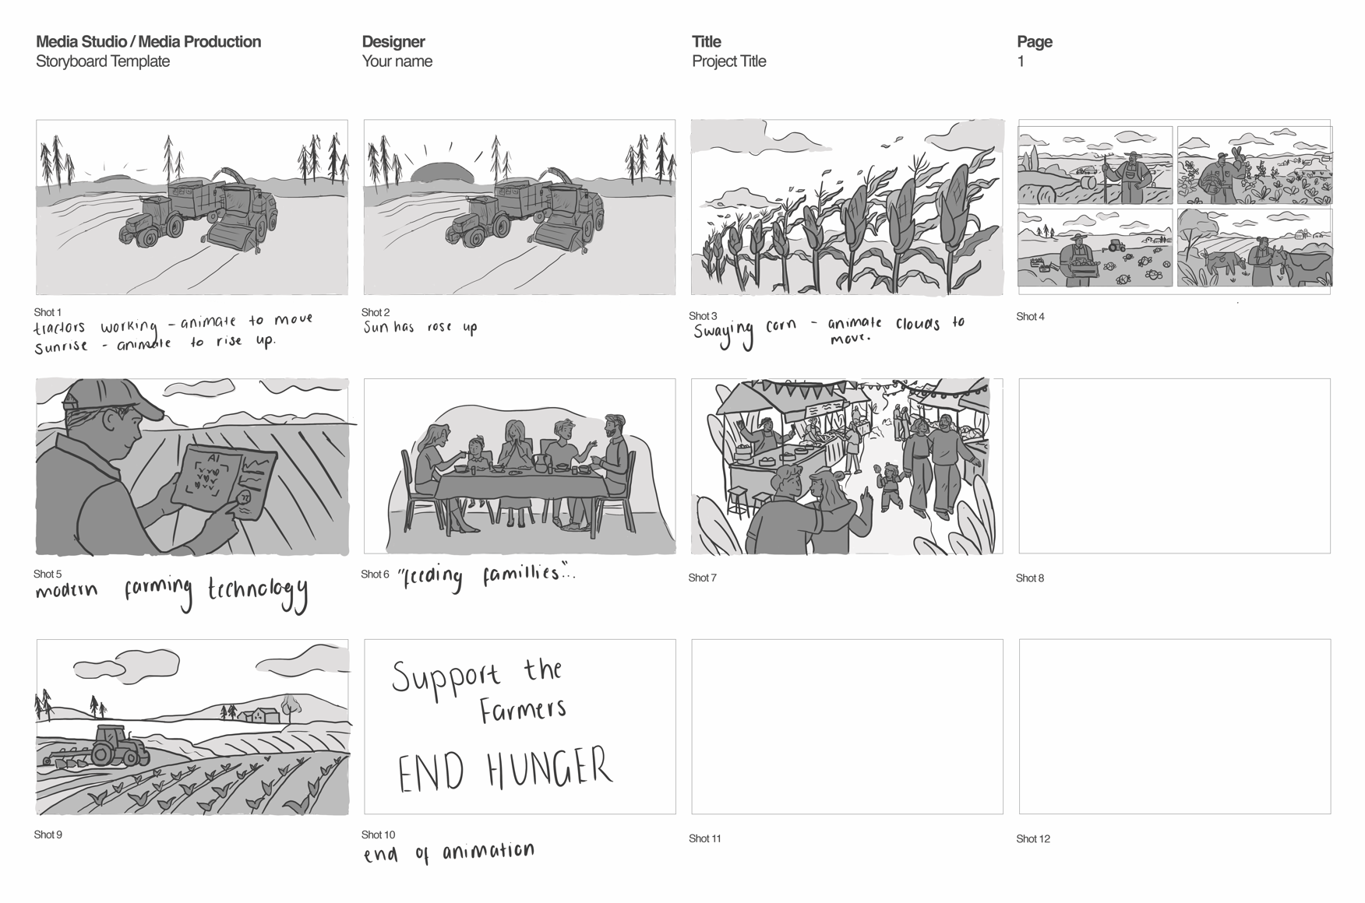

Post-Production

Production of Assets & VFXs
Please remove these paragraphs and briefly describe the process involved in producing your audio and visual assets and incorporating the visual effects during post-production.
For this assignment, you should independently produce all the audio and visual assets. Using images and videos provided by third parties or generated by Artificial Intelligence, including but not limited to Adobe Firefly, DALL.E, and Midjourney, is prohibited.

Reflective Statement
In this section, please remove this paragraph and reflect on the process of producing the video. Things you have done excellently, and things you could try another approach.

References
Please attach references, including your communication history with Generative AI, images, books, and journals during ideation, and audio sources, including background music and sound effects. Additionally, if you added extra Special Effects of After Effects from Online Tutorials, please add the links to this reference list.
Please strictly follow the UWE Bristol Harvard when referencing. https://www.uwe.ac.uk/study/study-support/study-skills/ referencing/uwe-bristol-harvard

