
Project Title
  - Media Studio / Teaching Block 1 Production report

Guillaume Evans
24030947

Pre-Production

Ideation
The goal I have chosen is SDG 16: Promote peaceful and inclusive societies for sustainable development, provide access to justice for all and build effective, accountable and inclusive institutions at all levels. I have chosen this goal as I volunteer for a couple humanitarian organisations, and so this issue is personal to me.
The concept of my audio-visual project is of an animation that takes the watcher through what SDG 16 is, and asks for their help at the end, with the animations being a way to illustrate what the narration talks about, producing a more emotional response from the watcher.

My CTA consists of three simple words: join the effort. This compels the watcher to lend a hand, after learning about the horrors that happen in our world, and how to stop them. It tells them that it is a joint effort that they can be a part of.

References:
Google Gemini
https://sdgs.un.org/goals/goal16

Script

🎬 SDG 16: The Pillars of Peace (10-Scene Script)
Scene | Visual | Audio/Narration | Focus (Issue/Hope)
1 | Opening Shot: A stark, fractured image of a community or city skyline. Low, ominous lighting. Smoking remains of buildings? | Narrator (Serious Tone): The foundations of peace, justice, and strong institutions are challenged daily across the world. | Introduction/The Threat
2 | Issue 1: Conflict. Quick, unsettling cuts: stylized shadows of armed conflict, a desperate escape, and a destroyed school. | Narrator: These challenges are rooted in conflict, a lack of education, and increasingly corrupt political forces. | Violence/Conflict
3 | Issue 2: Corruption. A hand placing a large wad of cash into a drawer labeled "Public Funds." The scene is secretive and dark. | Narrator: Corruption redirects funds from essential services (like healthcare and education), hindering delivery and widening the wealth gap. | Corruption/Theft
4 | Issue 3: Abuse of Power. A stylized depiction of a vulnerable individual being ignored or turned away by an overly fortified, uncaring institution. | Narrator: Without the Rule of Law, the innocent suffer, and the powerful act with impunity. | Rule of Law/Impunity
5 | Issue 4: Human Trafficking. A wide shot of a border or hidden location, focusing on the despair of people being moved against their will. | Narrator: Perhaps the more terrible crime, human trafficking: a brutal trade where exploiting for profit exposes a deep lack of humanity. | Human Trafficking
6 | Turning Point. The screen briefly goes dark, then a strong, single beam of light cuts through the darkness. | Narrator: Despite all of this, global peace and justice efforts are relentlessly turning the tide. | Shift to Hope
7 | Solution 1: Peacebuilding. Diplomats, community leaders, and aid workers collaboratively rebuilding a destroyed area or mediating a tense discussion. | Narrator: Dedicated effort from everyone is crucial to prevent violence, stop conflicts, build lasting peace, and connect communities. | Conflict Resolution
8 | Solution 2: Access to Justice. A gavel hitting a base. | Narrator: Transparent, accountable systems are being built. Legal aid and independent courts guarantee justice as a right, not a privilege. | Access to Justice
9 | Solution 3: Accountability. A government official is speaking at a town hall, surrounded by citizens who are actively engaging and asking questions. | Narrator: Strong institutions require openness and transparency for public accountability and engagement. | Accountability/Transparency
10 | Closing Shot: A wide, vibrant shot of diverse global citizens walking together confidently across a newly completed bridge or through a secure, thriving city. The SDG 16 logo is visible. | Narrator (Powerful, Hopeful): SDG 16 aims for a peaceful future by combating injustice and building strong, inclusive institutions. Join the effort. | Call to Action/Synthesis

Storyboard
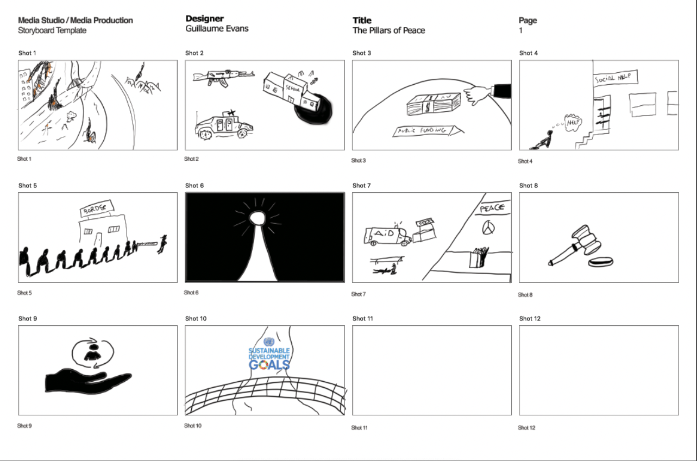

Post-Production

Production of Assets & VFXs
Please remove these paragraphs and briefly describe the process involved in producing your audio and visual assets and incorporating the visual effects during post-production.
For this assignment, you should independently produce all the audio and visual assets. Using images and videos provided by third parties or generated by Artificial Intelligence, including but not limited to Adobe Firefly, DALL.E, and Midjourney, is prohibited.

Reflective Statement
In this section, please remove this paragraph and reflect on the process of producing the video. Things you have done excellently, and things you could try another approach.

References
Please attach references, including your communication history with Generative AI, images, books, and journals during ideation, and audio sources, including background music and sound effects. Additionally, if you added extra Special Effects of After Effects from Online Tutorials, please add the links to this reference list.
Please strictly follow the UWE Bristol Harvard when referencing. https://www.uwe.ac.uk/study/study-support/study-skills/ referencing/uwe-bristol-harvard

