
=Project Title
  - Media Studio / Teaching Block 1 Production report

Student Name Cassius Butler – Broad
Student ID 25055305

Pre-Production

Ideation
In this section, please replace the texts and provide details of your team research in one of the United Nation Sustainable Development Goals:
- What is the Goal?
- Chosen concept of your Audio-Visual Project
- Chosen Call to Actions (CTA) of your Audio-Visual Project
- Related References (Video / Book / Image / Journal).

You could use Artificial intelligence-generated and third-party images for ideation purposes. However, using these images to produce the final video is PROHIBITTED.
My goal is to spread awareness of problems going on and bringing the topics back into consideration.
We have chosen to do Gender equality as our project as someone part of the lgbtq+ community I feel as the ideas of gender equality are very important in these spaces, general ideas of equality between groups is of big importance as I feel the divide is historic and the more we try to spreads the awareness of this issue the more people will start to understand the push for why equality is so important for us all cta

Gender equality in the uk
https://uwe.primo.exlibrisgroup.com/discovery/fulldisplay?docid=alma991003841477907511&context=L&vid=44UWE_INST:44UWE_INST&lang=en&search_scope=MyInst_and_CI&adaptor=Local%20Search%20Engine&tab=Everything&query=any%2Ccontains%2Cgender%20equality%20

No nonsense guide to equality
https://uwe.primo.exlibrisgroup.com/discovery/fulldisplay?docid=alma991002154539707511&context=L&vid=44UWE_INST:44UWE_INST&lang=en&search_scope=MyInst_and_CI&adaptor=Local%20Search%20Engine&tab=Everything&query=any%2Ccontains%2Cgender%20equality%20history&offset=0

Script
Gender and challenging stereotypes – animation
1st shot (scales between boys and girls) : “Theres always been an imbalance”
2nd shot – 3rd shot (showing different ways gender stereotypes are set): “from when we were young we have been put into these roles that support gender roles In our society”
4th shot (Why??): “But why is this, why do we have to be put into these closed off spaces depending on ones gender”
5th shot (Societal norms): “Due to the societal norms we have pre set notions on what we should be doing and how we should be presenting and the inequality between the two groups”
6th shot (cut) : LOUD SPEECH “for too long the scales of opportunity have been tipped !”
7th shot ( timeline of changes) “through history theres been a divide between the two, 1920 white women were given the choice to vote, before this it was only determined by mens votes??”
8th shot : “Where as its not the 1920s anymore in There are still places where we need to improve”
9th shot (quotes) : “Women don’t do as much as men” “She cant do it !” “boys don’t cry?”
10th shot (people join together to burn these words”: “We can all shut the **** up and try our best to not stick to these norms, do our best collectively to not push this agenda to our communities and future generations”

Storyboard
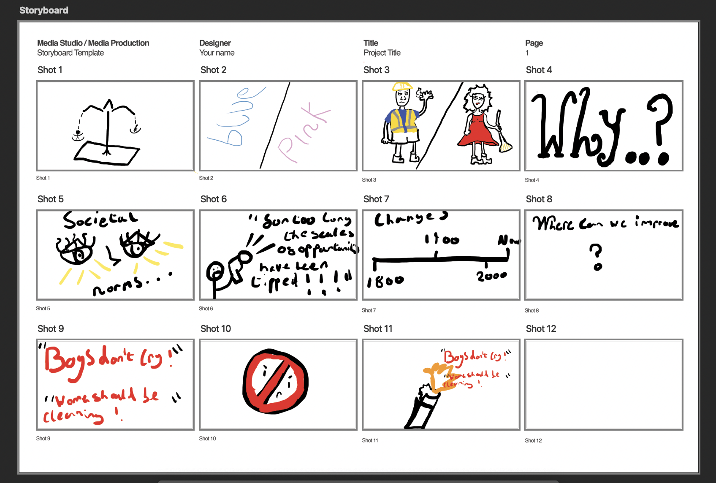

Post-Production

Production of Assets & VFXs
Please remove these paragraphs and briefly describe the process involved in producing your audio and visual assets and incorporating the visual effects during post-production.
For this assignment, you should independently produce all the audio and visual assets. Using images and videos provided by third parties or generated by Artificial Intelligence, including but not limited to Adobe Firefly, DALL.E, and Midjourney, is prohibited.

Reflective Statement
In this section, please remove this paragraph and reflect on the process of producing the video. Things you have done excellently, and things you could try another approach.

References
Please attach references, including your communication history with Generative AI, images, books, and journals during ideation, and audio sources, including background music and sound effects. Additionally, if you added extra Special Effects of After Effects from Online Tutorials, please add the links to this reference list.
Please strictly follow the UWE Bristol Harvard when referencing. https://www.uwe.ac.uk/study/study-support/study-skills/ referencing/uwe-bristol-harvard

