
Project Title
  - Media Studio / Teaching Block 1 Production report

Student Name: Santino Pinto
Student ID:

Pre-Production

Ideation
In this section, please replace the texts and provide details of your team research in one of the United Nation Sustainable Development Goals:
- Goal: No poverty
- Chosen concept of your Audio-Visual Project: No poverty
- Call to actions : Help donate for access to basic services eg travel
Donate to build the resilience of the poor reduce exposure and vulnerability to climate-related extreme events and other economic, social and environmental shocks and disasters.
Donate things which poorer people may need at charity shops e.g clothes
Give food to food banks=healthier food for poor=more able to go to work with healthy body
- Related References:
https://www.bbc.com/future/bespoke/follow-the-food/the-ageing-crisis-threatening-farming/
https://observer.co.uk/style/food/article/the-last-farmers-can-industry-survive-rising-costs-new-tax-and-climate-crisis
https://www.anthroencyclopedia.com/entry/humanitarianism
https://onlinelibrary-wiley-com.uwe.idm.oclc.org/doi/full/10.1111/sltb127
2
https://www-bloomsburycollections-com.uwe.idm.oclc.org/encyclopedia?docid=b-9798400693830 5

You could use Artificial intelligence-generated and third-party images for ideation purposes. However, using these images to produce the final video is PROHIBITTED.

Script
This was my first script created, I asked ai to make a 45 second script for a 2d animation based off of our no poverty brainstorm in figma. However to come up with my final script I edited it to make sure. It included more facts and made it more specific to what I would wan the script to sound like.
1st script: 🎬
2D Animation Script — “No Poverty Starts with Us” (45 seconds)
🎵 Soft, hopeful background music starts.
[0–8s | Scene 1 – Setup]
Visuals:
Animated city street — people walking, buses moving, kids laughing. One character looks sadly at an empty wallet in front of a grocery shop.
Voiceover (calm, empathetic):
Every day, people around us struggle to afford what many take for granted — food, travel, and a safe place to live.
[8–20s | Scene 2 – Conflict]
Visuals:
Split-screen: on one side, food prices rising on signs; on the other, a family sharing one small meal.
Then cut to an empty fridge and a long queue outside a food bank.
Voiceover (somber):
As prices rise, families face impossible choices.
Poverty isn’t just about money — it’s about losing access to health, opportunity, and hope.
[20–35s | Scene 3 – Resolution]
Visuals:
Transition to brighter colors — people donating clothes, handing over food, smiling.
Animated heart icons or hands linking together appear on screen.
Voiceover (hopeful, warm):
But we can make a difference.
Donate what you can. Support food banks.
Every act of kindness helps someone rebuild their future.
[35–45s | Scene 4 – Call to Action + Outro]
Visuals:
Characters form a circle holding hands. The background transitions to a globe with “No Poverty” text glowing.
On-screen text: “No Poverty starts with us.”
Voiceover (confident, inspiring):
Together, we can end poverty — one action at a time.
Text on screen:
#ActNow #NoPoverty #UNSDG1
Final script:
🎬 Final Script (Revised): “End All Poverty – Together We Rise” (45 Seconds)
[0–10s | Exposition – The Reality Check] 🎵 Soft, emotional piano fades in. Voiceover (calm, sincere): Every night, more than 700 million people go to bed hungry.
That’s nearly 1 in 10 of us — struggling to afford food, transport, or even a safe place to sleep. 4.5 million children are growing up in poverty in the UK. Poverty isn’t just being poor… it’s the child skipping school to help her family survive.
[10–20s | Rising Action – A Turning Point] Voiceover (hope building): But it doesn’t have to be this way. When we make food affordable, transport accessible, and share resources fairly, we give people more than aid — we give them a chance. 4 A chance to live life happily, not just survive.
[20–30s | Climax – The Vision] Voiceover (inspired tone): Imagine a world where no one has to choose between a meal and a bus fare. 5 Where every person — no matter where they’re born — can stand tall, work, learn, and dream freely. That world is possible.
pause 6
[30–40s | Falling Action – The Call Within] Voiceover (empathetic, urgent): You have the power to make that world real. A small donation can feed a family for a week. 7 A few spare clothes can help someone find a job. 8 Every act — no matter how small — breaks the cycle for someone. 9
[40–45s | Resolution / Call to Action – Together We Rise] 🎵 Music swells — hopeful strings and percussion. Voiceover (strong, uplifting): Together, we can end poverty — one act of kindness, one donation, one opportunity at a time. 10 The power to change lives is in our hands. Let’s act now.
🖥️ On-screen text: “No Poverty Starts With Us.” #ActNow #NoPoverty #UNSDG1
🎵 Music swells, then fades out.
Storyboard

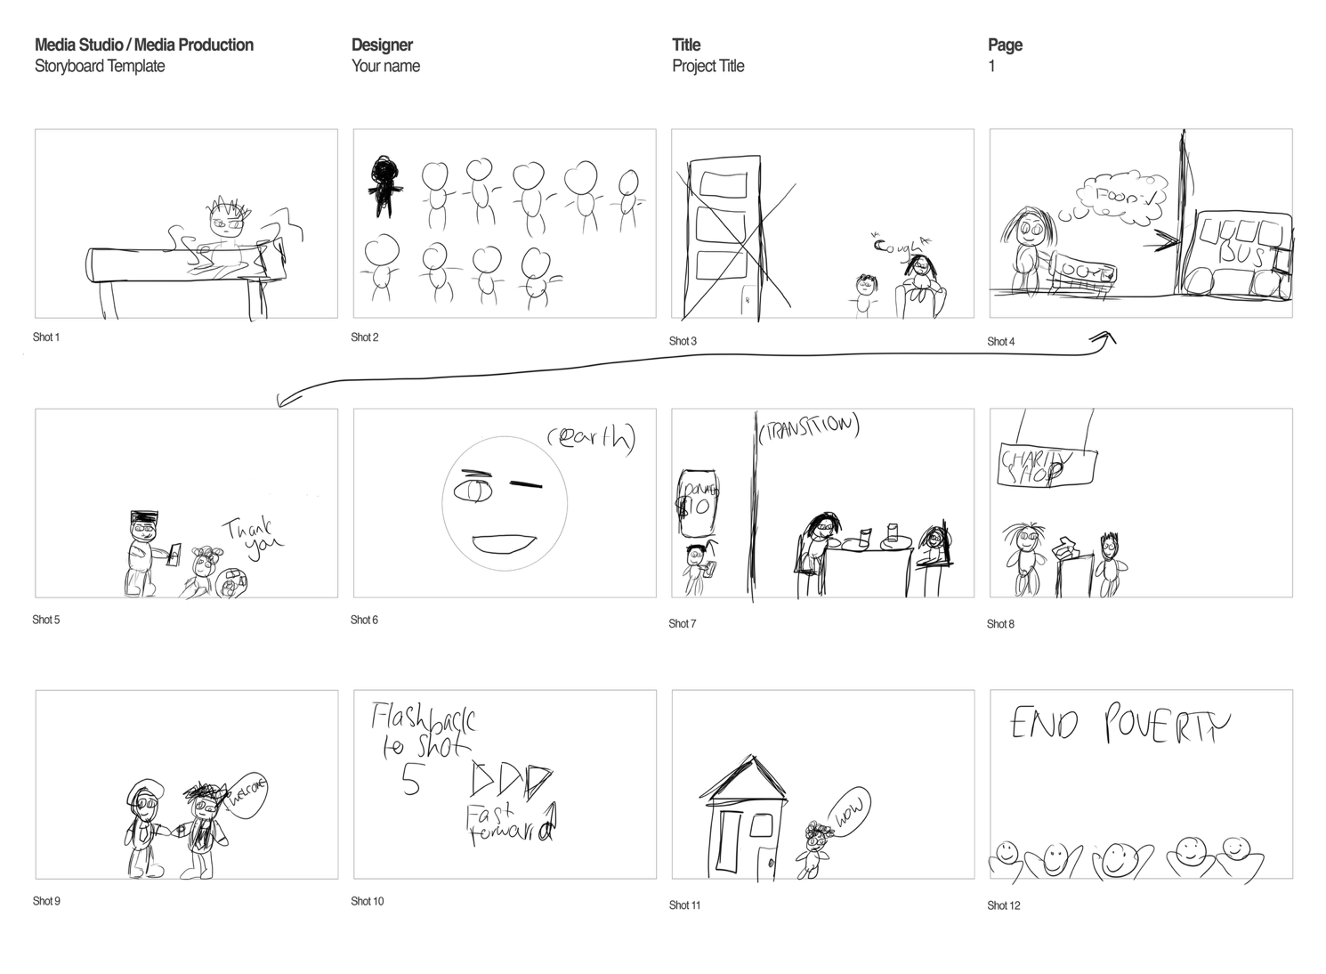

Post-Production

Production of Assets & VFXs
Please remove these paragraphs and briefly describe the process involved in producing your audio and visual assets and incorporating the visual effects during post-production.
For this assignment, you should independently produce all the audio and visual assets. Using images and videos provided by third parties or generated by Artificial Intelligence, including but not limited to Adobe Firefly, DALL.E, and Midjourney, is prohibited.

Reflective Statement
In this section, please remove this paragraph and reflect on the process of producing the video. Things you have done excellently, and things you could try another approach.

References
Please attach references, including your communication history with Generative AI, images, books, and journals during ideation, and audio sources, including background music and sound effects. Additionally, if you added extra Special Effects of After Effects from Online Tutorials, please add the links to this reference list.
Please strictly follow the UWE Bristol Harvard when referencing. https://www.uwe.ac.uk/study/study-support/study-skills/ referencing/uwe-bristol-harvard

