
=Project Title
  - Media Studio / Teaching Block 1 Production report

Student Name Cassius Butler – Broad
Student ID 25055305

Pre-Production

Ideation
In this section, please replace the texts and provide details of your team research in one of the United Nation Sustainable Development Goals:
- What is the Goal?
- Chosen concept of your Audio-Visual Project
- Chosen Call to Actions (CTA) of your Audio-Visual Project
- Related References (Video / Book / Image / Journal).

You could use Artificial intelligence-generated and third-party images for ideation purposes. However, using these images to produce the final video is PROHIBITTED.
My goal is to spread awareness of problems going on and bringing the topics back into consideration.
We have chosen to do Gender equality as our project as someone part of the lgbtq+ community I feel as the ideas of gender equality are very important in these spaces, general ideas of equality between groups is of big importance as I feel the divide is historic and the more we try to spreads the awareness of this issue the more people will start to understand the push for why equality is so important for us all cta

Gender equality in the uk
https://uwe.primo.exlibrisgroup.com/discovery/fulldisplay?docid=alma991003841477907511&context=L&vid=44UWE_INST:44UWE_INST&lang=en&search_scope=MyInst_and_CI&adaptor=Local%20Search%20Engine&tab=Everything&query=any%2Ccontains%2Cgender%20equality%20

No nonsense guide to equality
https://uwe.primo.exlibrisgroup.com/discovery/fulldisplay?docid=alma991002154539707511&context=L&vid=44UWE_INST:44UWE_INST&lang=en&search_scope=MyInst_and_CI&adaptor=Local%20Search%20Engine&tab=Everything&query=any%2Ccontains%2Cgender%20equality%20history&offset=0

Script
Gender and challenging stereotypes – animation
1st shot (scales between boys and girls) : “Theres always been an imbalance”
2nd shot – 3rd shot (showing different ways gender stereotypes are set): “from when we were young we have been put into these roles that support gender roles In our society”
4th shot (Why??): “But why is this, why do we have to be put into these closed off spaces depending on ones gender”
5th shot (Societal norms): “Due to the societal norms we have pre set notions on what we should be doing and how we should be presenting and the inequality between the two groups”
6th shot (cut) : LOUD SPEECH “for too long the scales of opportunity have been tipped !”
7th shot ( timeline of changes) “through history theres been a divide between the two, 1920 white women were given the choice to vote, before this it was only determined by mens votes??”
8th shot : “Where as its not the 1920s anymore in There are still places where we need to improve”
9th shot (quotes) : “Women don’t do as much as men” “She cant do it !” “boys don’t cry?”
10th shot (people join together to burn these words”: “We can all shut the **** up and try our best to not stick to these norms, do our best collectively to not push this agenda to our communities and future generations”

Storyboard
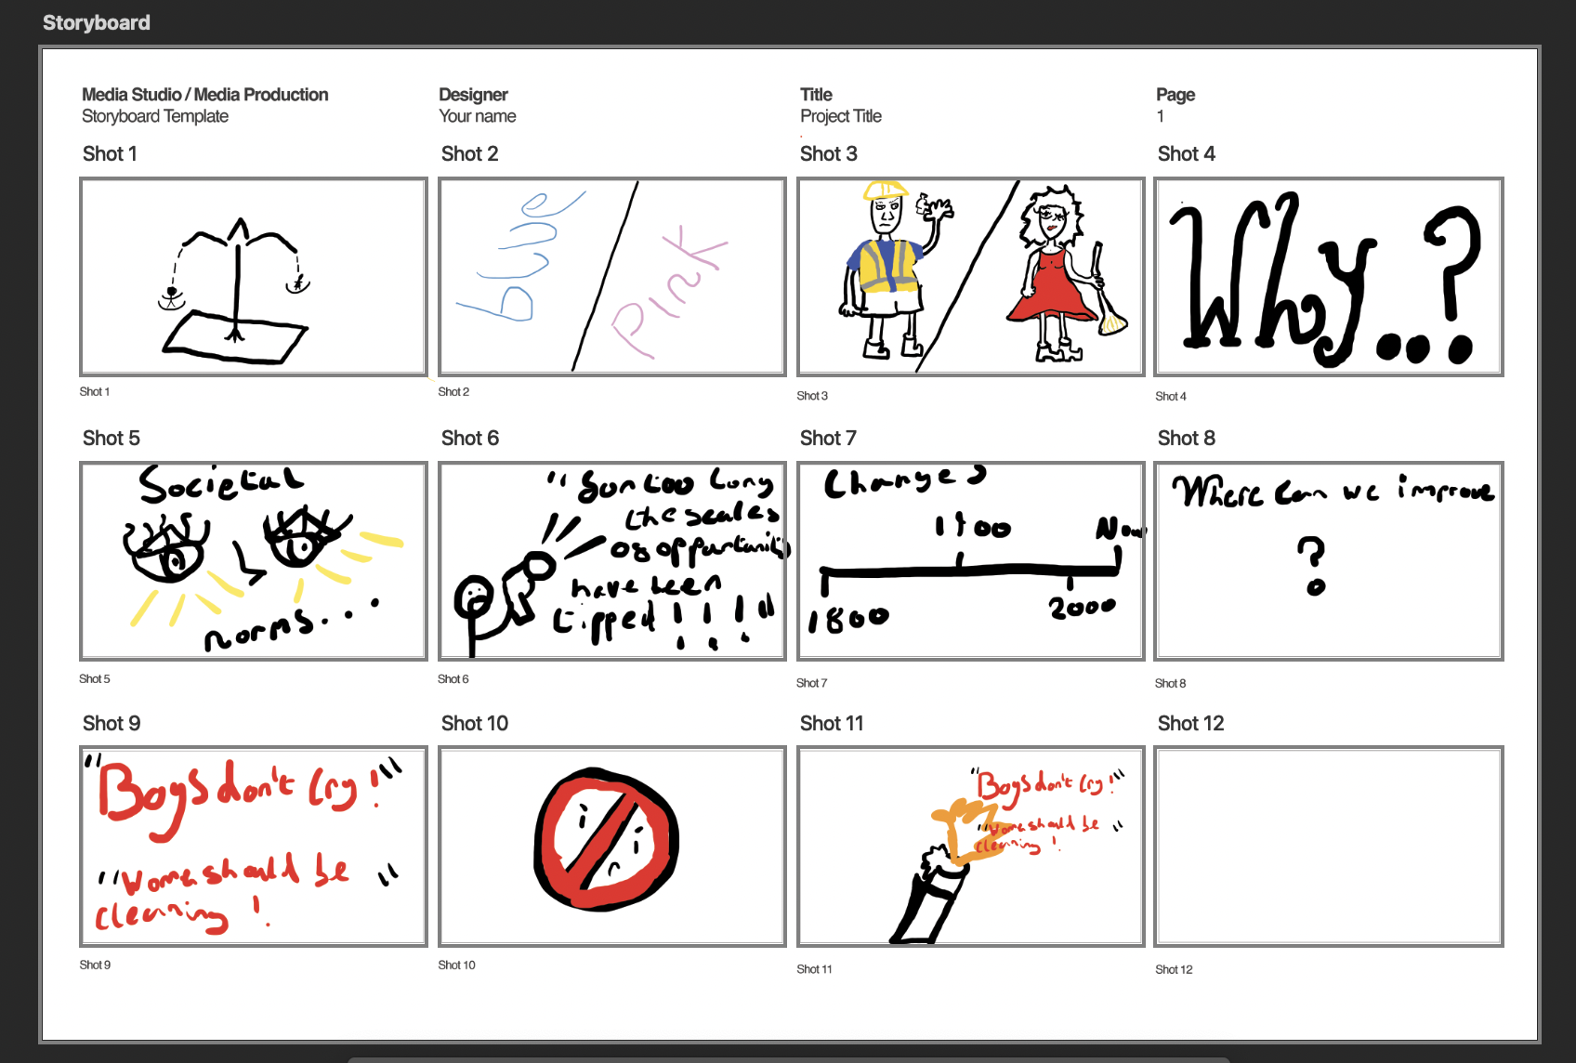

Post-Production

Production of Assets & VFXs
I started by producing a storyboard drawing, Using this it gave me a good bassline to improve on so I hired a drawing tablet which I then used to create a story board on photoshop, thus allowing me to pre make assets for my animation as I was able to reuse drawn assets from the storyboard in my final piece. I then also made the script to go along with the scenes using my voice as away to explain what was happening on the screen and further emphasising my points. I decided I wanted my starting scene to use the scales and show them going up and down symbolising the divide between the men and women in the world. I did this by creating three versions of the image and making a stop motion loop to make it appear it is going up and down, with my drawings this use of stop motion became a main point for me as it allowed me to use my drawings easily and compose them to make a more dynamic scene. I then used shaped layers to show the colours coming up on each side for the second scene using the stop watches anchor points to get to where I wanted it to be at the same time as each other showing the divide on the screen. I then did another animation after with the eyes blinking and presenting the social norms again using multiple stills to create an animation. I wanted the text to relate to my speech when I said “Why?” creating a circle around the big why for the text path to follow adding a bit of dynamics to the shot, Using photoshop I created a new drawing of my hand so I could add the interactivity on the screen creating the magnifying glass to create a zoom effect using stop motion stills to zoom in on the 1920 areas of the timeline. I then created a scene in which it zooms into centring the no women sign emphasising the point of the divide and then slowing zooming out to the change showing the contrast between the two times of where women are able to vote after. I then used one of my images from my storyboard which overlayed text behind spouting typical stereotypes of men and women on top and bottom then using the hand I created earlier for the magnifying glass I was able to add a picture of a lighter which then burns these words using stop motion.

Reflective Statement
With my animation I wanted to be able to push a point in which supports the chosen call to action and brings awareness around it. I did come out of this project feeling accomplished with the skills I had learnt from being able to use after effects, I do wish I scheduled more time to work on this project as I believe I underestimated the depth the app goes into. I do feel as if it was a decent first attempt of an animation, especially using a new software where I felt it challenging to understand at first, using the stopwatches and keyframes but this was overcome when I spent some time trying to fix my problems and going back when It didn’t work. If I was to do It again I would put some more thought into the planning as I feel I was trying to fit allot in a short amount of time so It came off a little in-cohesive. I believe I could’ve fixed this by thinking about the pacing of the project and the most important points and knowledge to put across.

References
Please attach references, including your communication history with Generative AI, images, books, and journals during ideation, and audio sources, including background music and sound effects. Additionally, if you added extra Special Effects of After Effects from Online Tutorials, please add the links to this reference list.
Please strictly follow the UWE Bristol Harvard when referencing. https://www.uwe.ac.uk/study/study-support/study-skills/ referencing/uwe-bristol-harvard
https://uwe.primo.exlibrisgroup.com/discovery/fulldisplay?docid=alma991002154539707511&context=L&vid=44UWE_INST:44UWE_INST&lang=en&search_scope=MyInst_and_CI&adaptor=Local%20Search%20Engine&tab=Everything&query=any%2Ccontains%2Cgender%20equality%20history&offset=0
